Final presentation of the project

IzyMartek



Members: Jocelyn Navarro

Cesar Negrete

Professor: Helton Smith

Computer engineering

table of Contents

Conclusions  3

Group reflection  3

Methodology  4

Evidence  4

Interests  10

# Conclusions

Jocelyn Navarro: In conclusion, during the course of the project as a team we had ups and downs, since at the beginning we had a bit of trouble with the coordination issue and we wanted to risk learning something new, flutter , with which we created our application. Although it was difficult, we were satisfied with the result of our application, since despite having errors we were able to correct them thanks to the advice of our teacher.

Cesar Negrete: In conclusion, we had problems with timing, since I was doing my internship, so I only had a few days available to continue advancing, the good thing is that we were able to coordinate our times well with my partner. As for Flutter, we wanted to use this because we wanted to learn something new, and they were teaching it to me at my internship place. Along the way, we had some problems with the design of the application, since it was very basic, but thanks to the advice of our teacher we were able to change this.

# Group reflection

As a group, we learned during the course of the project to organize ourselves better, to express our ideas and to discuss different changes that we would like to make. We also learned to work in a more organized and collaborative way as a team.

The tasks were managed equally, with each person collaborating best in what was easiest for them.

What worked well within the group was communication, as we could both give ideas of what to add or change in the project. As for what to improve was our organization, although it is true that in the end we managed to organize ourselves, at first it was too difficult for us.

# Methodology

We use the agile Kanban methodology by creating a Kanban Board to show all the tasks we need to perform within the development of the project.

For the efficient management of our marketplace development , we used a Kanban board to visualize and manage all the tasks required during the project lifecycle. This methodology allowed for high flexibility and visibility in the progress of the work.

To document and manage the workflow, we used Trello as a key tool. Trello allowed us to create and maintain an interactive Kanban board, making it easy to plan, track and update tasks.

This agile methodology and the selected tools ensured effective project management, allowing rapid adaptation to changes and fluid communication between team members.

# Evidence

App

**

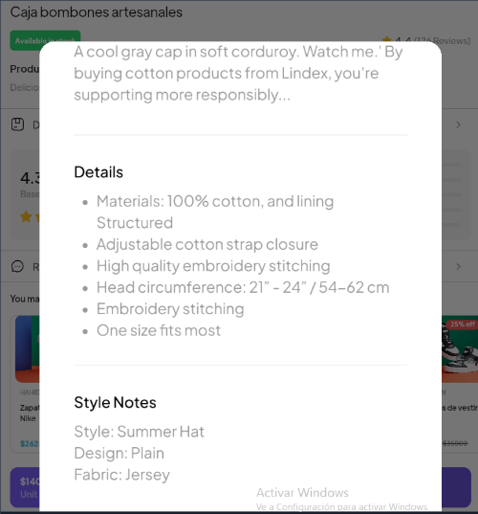

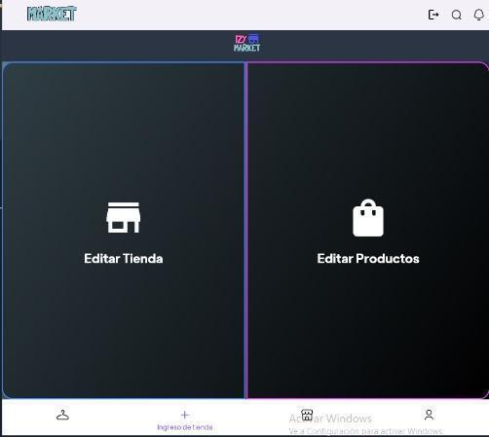

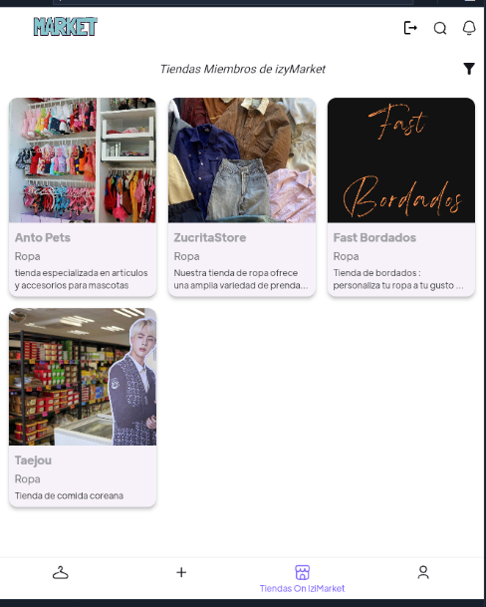

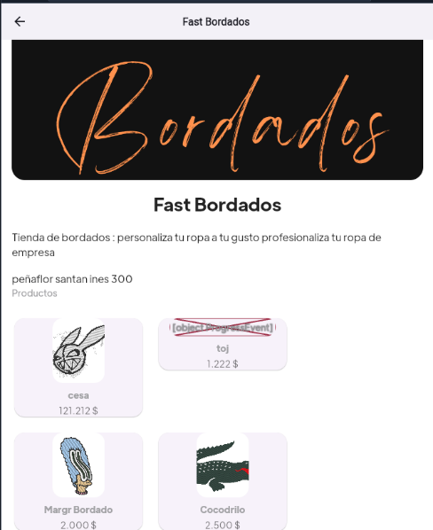

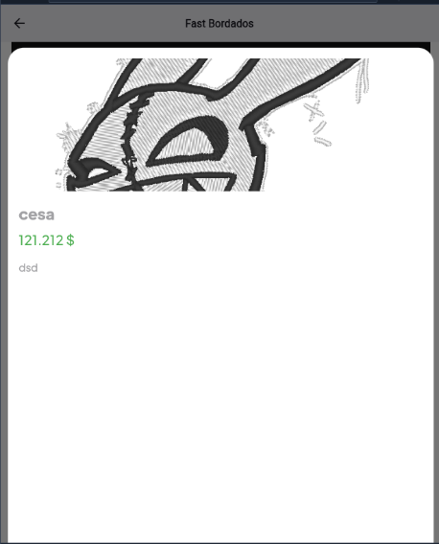

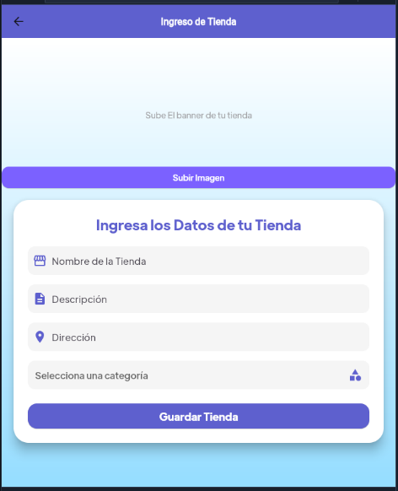

Code

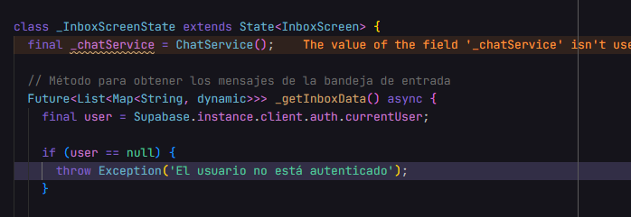

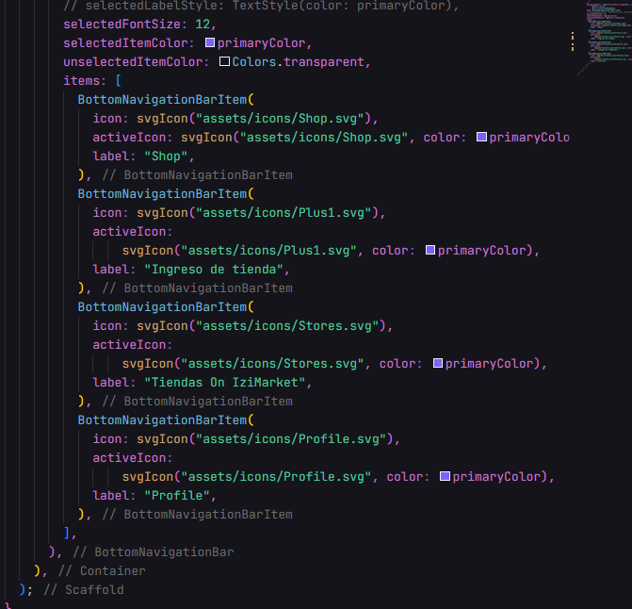

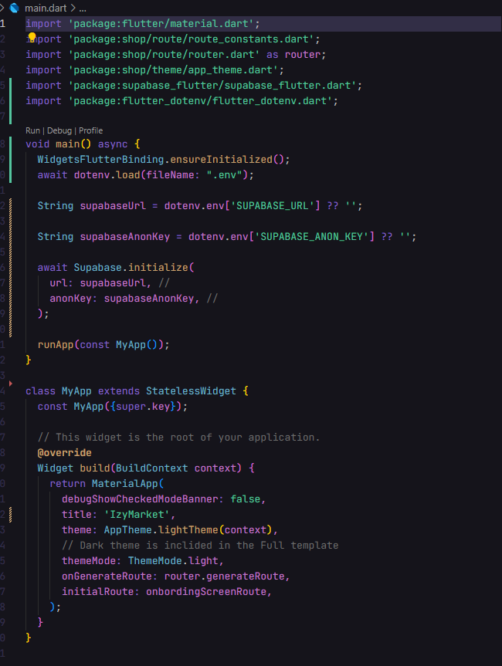  
  
  
  
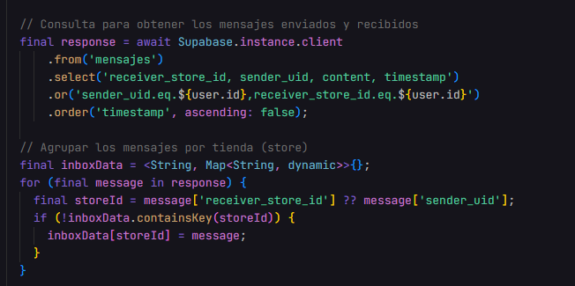

# Interests

Our professional interests from the beginning were linked to the creation of mobile applications, since both as a team liked both web and mobile development. Thanks to the development of this project we were able to learn a lot about a new software development framework , which was Flutter , although we still have a lot to learn about it, at least we learned the basics to continue learning about this framework later on .

Competencies

* Develop a software solution using techniques that allow systematizing the development and maintenance process, ensuring the achievement of objectives.
* Build data models to support the organization's requirements according to a defined and scalable design over time.
* Knowledge of web and mobile development.
* Design and Development: This competency allows you to create a solution that is functional and easy to use, which is key to helping micro-entrepreneurs who have no prior experience in digitalization.
* Technology Assessment: Evaluating and applying appropriate technologies ensures that the software is efficient and tailored to the specific needs of users.
* Innovation and Collaboration: Thanks to the capacity for innovation and collaboration with other professionals, we can create a tool that not only solves the current problem, but also adapts to future needs.
* Critical Thinking: Critical thinking is necessary to identify the specific problems that microentrepreneurs face and design a solution that effectively addresses the problem.
* Ethics and Learning: Thanks to ethics we will ensure that the software respects the ethical principles that we have learned during our student process. On the other hand, thanks to continuous learning we can improve the software as technologies evolve.